1. 30 Munroe St and linksys12

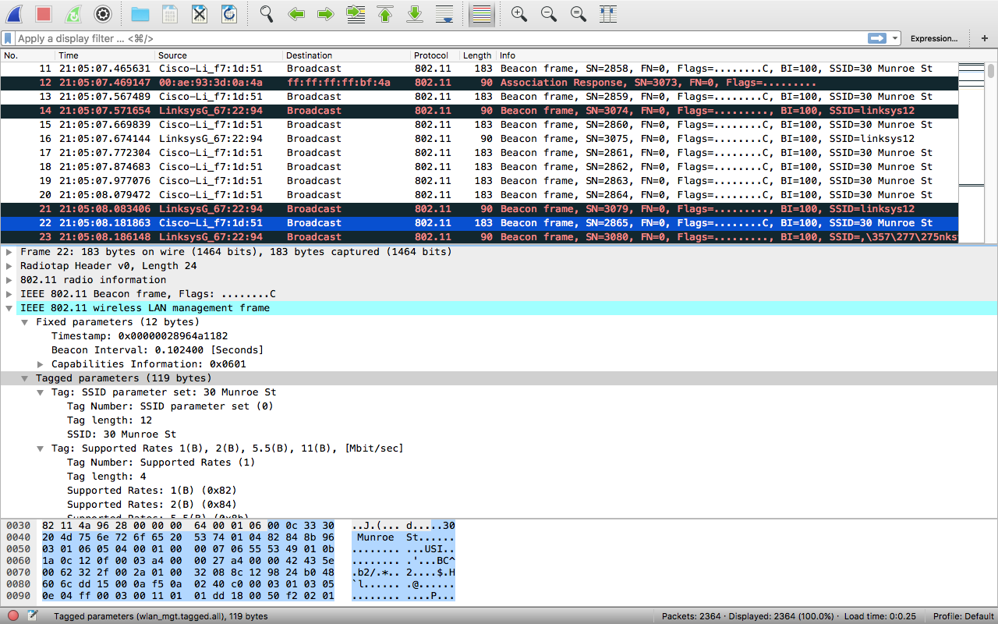

1. the interval time for both is 1024 seconds
2. 30 munroe street, src: 00:16:b6:f7:1d:51
3. dest: ff:ff:ff:ff:ff:ff, i.e., the Ethernet broadcast address
4. MAC BSS id on beacon frame for 30 munroe: 00:16:b6:f7:1d:51
5. Support rates:1.0, 2.0, 5.5, 11.0 Mbps. extended rates: 6.0, 9.0, 12.0, 18.0, 24.0, 36.0, 48.0, 54.0 Mbps

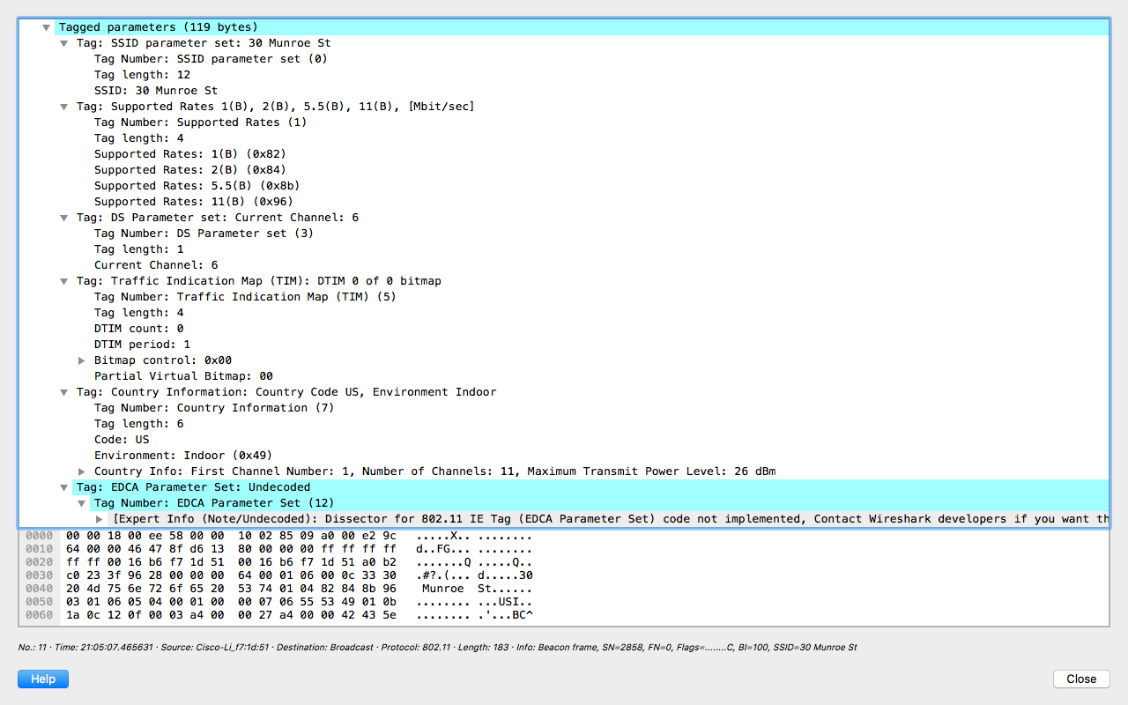

1. The TCP SYN is sent at t = 24.811093. The MAC address for the host = 00:13:02:d1:b6:4f. dest MAC, = 00:16:b6:f4:eb:a8. The BSS MAC = 00:16:b6:f7:1d:51. Host IP = 192.168.1.109.
2. 1. The TCP SYNACK is received at t = 24.827751 seconds.
   2. The MAC sender = 00:16:b6:f4:eb:a8, which is the 1st hop.
   3. Dest. MAC(host) = 91:2a:b0:49:b6:4f.
   4. BSS mac = 00:16:b6:f7:1d:51.
   5. Server IP for TCP SYNACK is 128.199.245.12 (gaia.cs.umass.edu)
   6. Dest = 192.168.1.109 (the wireshark PC)